Principles of Engineering
Final Exam Study Guide

Energy and Power
Mechanisms
Simple Machines – Lever
A first class lever in static equilibrium has a 50lb resistance force and 15lb effort force. The lever’s effort force is located 4 ft from the fulcrum.
- What is the actual mechanical advantage of the system?
- Using static equilibrium calculations, calculate the length from the fulcrum to the resistance force.

An industrial water shutoff valve is designed to operate with 30 lb of effort force. The valve will encounter 200 lb of resistance force applied to a 1.5 in. diameter axle.
- What is the required actual mechanical advantage of the system?
- What is the required wheel diameter to overcome the resistance force?
Simple Machines – Pulley System
A construction crew lifts approximately 560 lb of material several times during a day from a flatbed truck to a 32 ft rooftop. A block and tackle system with 50 lb of effort force is designed to lift the materials.
- What is the required actual mechanical advantage?
- How many supporting strands will be needed in the pulley system?

Simple Machines – Inclined Plane
A civil engineer must design a wheelchair accessible ramp next to a set of steps leading up to a building. The height from the ground to the top of the stairs is 2 ft. Based on ADA codes, the slope must be 1:12 or less. Slope is equal to the rise of the ramp divided by the run of the ramp.
- Using the ADA code, what is the allowable minimum length of the ramp base?
- Using the known height and calculated base length, what is the length of the slope of the ramp?

Gears
A simple gear train is composed of three gears. Gear A is the driver and has 8 teeth, gear B has 24 teeth, and gear C has 16 teeth.
- If the output is at C, what is the gear ratio?
- If gear A rotates at 60 rpm, how fast is gear C rotating?
- If the output of torque at gear C is 150 ft·lb, what is the input torque at gear A?
A compound gear train is composed of four gears, A, B, C, and D. Gear A has 10 teeth and is meshed with gear B. Gear B has 20 teeth and shares a shaft with gear C, which has 16 teeth. Gear C is meshed with gear D, the output gear. Power is supplied at gear A with 100 ft·lb of torque and is traveling at1600 rpm.
- The necessary torque output for the system is 500 ft·lb. What should the gear ratio of the system be?
- With a system torque output of 500 ft·lb, how many teeth should gear D have?

Electricity

For each of the resistors shown below, use Ohm’s law to calculate the unknown quantity. Be sure to put your answer in proper engineering notation and use the correct units.
For each of the circuits shown below, calculate the value for R_{T}. Be sure to put your answer in proper engineering notation and use the correct units.
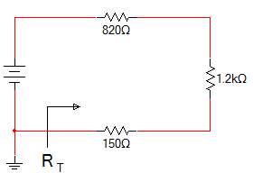 | 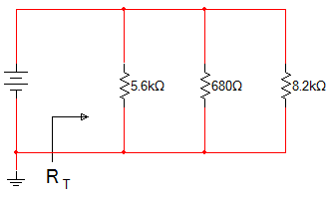
Work/Power
A student lifts a 50 pound (lb) ball 4 feet (ft) in 5 seconds (s).
- How many joules of work has the student completed?
- How many watts of power are used to lift the ball?
Thermodynamics
A 1.00kg piece of aluminum metal at 90.0°C is placed in 4.00 liters (=4.00 kg) of water at 25.0°C.
- Determine the final temperature (T_{f}).
A 3/16 in. thick acrylic testing box with dimensions of 10.0 in. x 10.0 in. is covered with an unknown 0.50 in. insulation material.
- Determine the thermal conductivity for the insulating material if a 25.0W bulb is used to heat the box. The bulb maintains the inside temperature at 10.0ºC higher than the outside temperature.

One way to calculate heat loss through a wall is with the formula: Q = U AΔT
A 6 ft x 12 ft wall has an U-value of .35
- Calculate the heat loss through the wall if the temperature on one side is 95 °F and the temperature on the other side is 80 °F. Be sure to show all units. [3 points]
- What is the R-value of the wall? Be sure to show all units. [2 points]
(answer precision 0.0)

Materials and Structures
Centroids
Calculate, label, and dimension the and components. Indicate the location of the centroid using the symbol.

1.  0.50 in.  0.75 in. |  | Formula(s) | Substitute / Solve | Final Answer
1 in.
0.5 in.
2. | Formula(s) | Substitute / Solve | Final Answer
Beam Deflection
Calculate the cross-sectional area, Moment of Inertia, and beam deflection, of a beam measuring 1.5in(horizontally) and 5.5in(vertically), given a load of 250 lbf, a Modulus of Elasticity of 1,510,000 psi, and a span of 12 ft.

Truss Forces
Calculate the truss forces in the following truss.
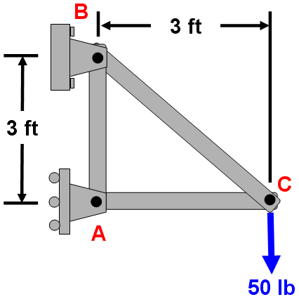

Stress / Strain
A ¼ in. diameter rod must be machined on a lathe to a smaller diameter for use as a specimen in a tension test. The rod material is expected to break at a normal stress of 63,750 psi. If the tensile testing machine can apply no more than 925 lb of force to the specimen, calculate the maximum rod diameter that should be used for the specimen. (precision of 0.000)
A 100 ft long steel wire has a cross-sectional area of 0.0144 in.². When a force of 270 lb is applied to the wire, its length increases by 0.75 in. Determine:
a. The stress (precision of 1000)
b. The strain (precision of 0.00000)
c. The modulus of elasticity of the steel (precision of 1,000,000)

Control Systems
Machine Control
Discuss the difference between an analog device and a digital device.
Discuss the difference between an open loop and a closed loop in a sensor system. Is one better than another? Why?
Fluid Power
A pneumatic system is producing 100 lb/in.² of gauge pressure. A cylinder is needed to press an adhesive label onto a product. It has been determined that 5 lb of force is optimal to complete this task.
- What is the required area of the pneumatic cylinder?
- What is the required diameter of the pneumatic cylinder?

The gauge pressure of a pneumatic cylinder reads 20 lb/in.² when the volume is 30 in.³. The cylinder is compressed until the gauge reads 60 lb/in.². Assume standard atmospheric pressure (14.7 psi).
- What is the absolute pressure before and after the cylinder gas is compressed?
- What is the volume in the cylinder after the gas is compressed?

A 60 ft³ compressor tank container has a gauge pressure of 160 lb/in.² and a temperature of 70 °F. The temperature after some time decreases to 40 °F. Find the final pressure in the tank. Assume standard atmospheric pressure.
- What are the absolute temperature readings initially and after the temperature decreases?
- What is the absolute pressure of the system before the temperature decreases?
- What is the absolute pressure of the system after the temperature decreases?

Statistics / Kinematics
Projectile motion
A motorcycle takes off from a ramp with the following measurements: Take-off angle = 30° Take-off speed = 100 ft/sec
- What was the motorcyclist’s initial vertical velocity? (Accuracy = 0)
- What was the horizontal distance between the take-off and landing points? Assume that both points exist on the same horizontal plane. Use
-32.15 ft/sec2 for acceleration due to gravity. (Accuracy = 0.0)

Statistics
- One coin is flipped four times in a row. What is the probability of flipping two heads and two tails?
- A set of two die are rolled twice. What is the probability of rolling “snake eyes” on both rolls?
Design Process
Each of the following five statements represents a step in a design process.
There are 12 design process steps listed in the answer bank. Identify which of the steps from the answer bank is being represented by each statement by writing the step number on the line provided.
- A team of students conduct trial runs to determine the ability of the marble sorter to separate marbles by color.
- Students in small groups list ideas based on the constraints identified in the design brief.
- Students build their marble sorter design.
- A team of students modifies the sensing system of their design after the device fails to accurately separate all marbles.
- A team of students uses a decision matrix to help narrow down their ideas.

